
~ ~"l,~
",=c! -d~.' -,'
'.','--.-----/
CAUSSES ~IERIDIONAUX
The aim of "larue. village d'Europe", is to bring together all the people of many nationalities who live on the Plateau du Lamc and to establish contacts with other associations and people in Europe. who wish to take part in cultural exchanges. In general we wish to participate. on our level, in the construction of a united Europe while respecting the diversity of its cultures. a Europe open to all and not inward looking.
The« CPIE (Centre Permanent d'initiatives pour l'Environnement) des Causses Meridionaux» is a group for the development and protection of the environment. It is composed of councillors, farmers and foresters, bur also of various associations of naturalists and hunters. Its overall object is to safeguard and promote the development of the «Causses» (limestone plateaux) of the departments of the Gard and Herault.
Dear reader.
1"
This year. our two associations organize a fifth international exhibition of Mail Art on the following theme
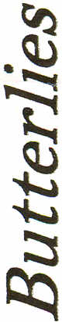
Butterflies

Light winged buterflies and moths, who represent poetry aile! love. Do you know of the «butterfly syndrome»? : Can the fluttering of my wings in ~lI\ng bring on a storm in New york?

I was an unloved caterpillar, and I have become a butterfly that flies here and there and can land in many places.

And.uDo you know that I, a lepidopterous insect, anl')here to warn you of the health of our ecosystems!

U) o o N
It is our pleasure to invite you to participate by sending mail illustrated in any way you please (drawing. painting, photograph, collage. object. sculpture. etc.). on the support of your choice and in the format that suits you best. The only requirement is the stamp, cancelled, with the address of the recipient and your return address within the illustrated portion. You may, if you wish, send several creations.
And don't hesitate to pass this invitation on to others.
The deadline for entries is July 15th 2007. at the following address:

We invite you to come discover the works we receive from you, which will be presented from the 1st to the 10th August in Le Caylar; on the village square. The exhibition will then-travel to several villages and cities of our region.
Larzac Village d’Europe
86, route de St-Pierre
34520 Le Caylar - France
The contributed works will not be subject to any commercial exploitation, and will not be involved in any contest.
We will subsequently prepare a souvenir document listing the name and address of all participants. This will be sent to all involved.
We would be delighted if you feel able to accept our invitation to take part in this project. and to everyone we send our best wishes.
President of Larzac_{o} village dOEurope Hubert Martin
President of the CPIE des Causses Meridionaux Andre Gay
<'''' ••.
Le Caylar+ ~'"
C'_
.. -
Mas s if r_r'--
[ en t r a I .---Lod'; _
r-" eve
_ ... -.-~-
o
Nimes
o Mompellier
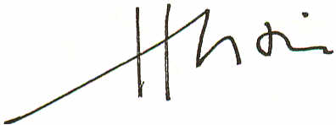
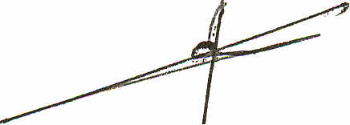
Beziers
o
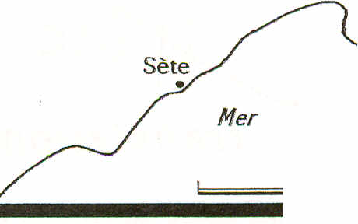
Miditerram§e
Narbonne
50km
For all additional information, write to eurolarzac@wanadoo.fr or ring 00.33 (0)4.67.44.51.44 or 00.33 (0)4.67.44.75.79
Le Caylar, 400 inhabs, is situated on the limestone plateau (or • causse .) du Larzac at 750m alt., at the south end of the Massif Central, between Millau and Lodeve.
Larzae, village d'Europe: Route de St-Pierre 34520 LE CAYLAR - France - Tel.: 04.67.44.51.44 CPIE des Causses Meridionaux: Rue de I'Ecole 34520 LE CAYLAR - France - TeL: 04.67.44.75.79

